**BMS INSTITUTE OF TECHNOLOGY & MANAGEMENT**

Yelahanka, Bangalore – 560 064

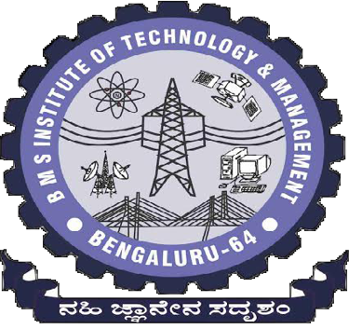Department of Computer Science & Engineering

Report for the Project work

**“ANAGRAMS USING PYTHON PROGRAMMIN”**

Submitted By:

Mohmmed Daaniyaal 1BY15CS051

Abhishek B 1BY15CS005

Under the Guidance of

Mrs. Mari Kirthima A

2017-2018